Ans -1) select name, continent from country;
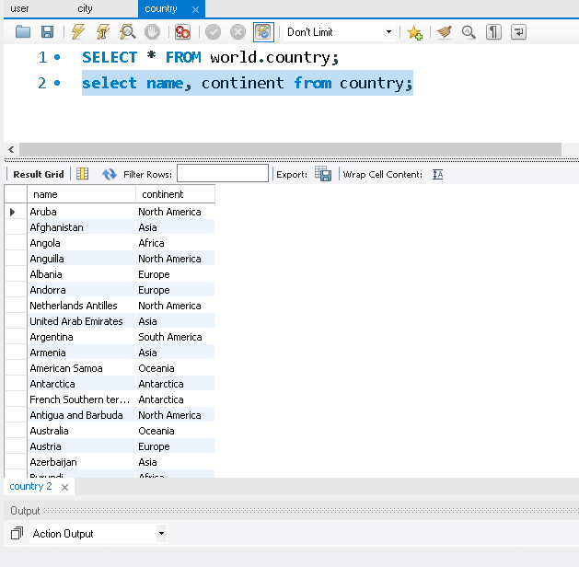
Q1) select name from city where CountryCode="JPN";

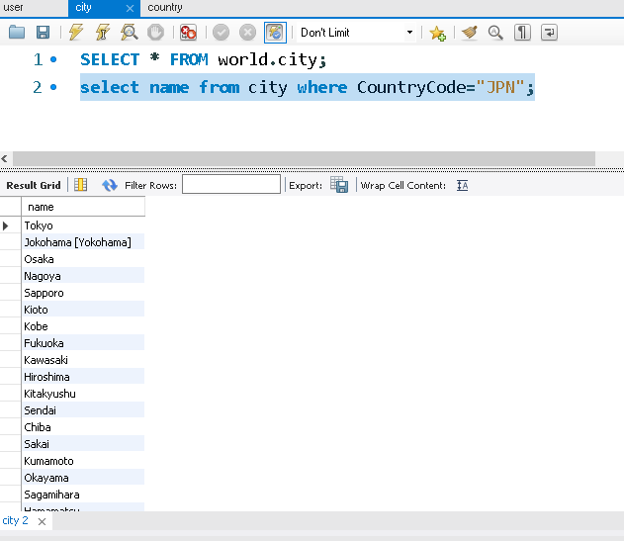

Q- 2) select Name, Population from country where population>100000000;

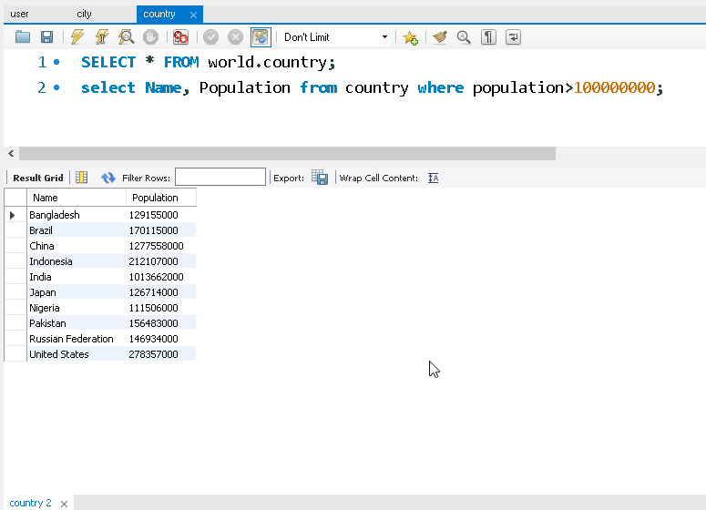

Q2) select name, population from country where Population between 1000000 and 5000000;

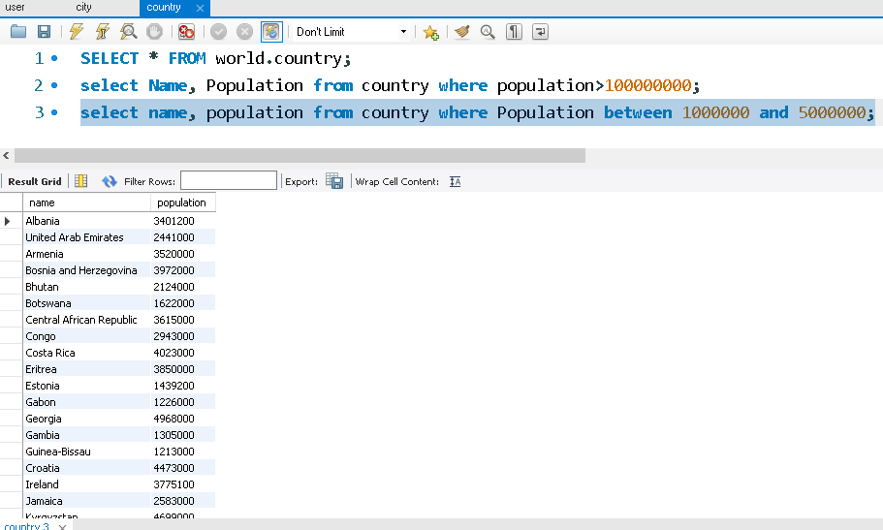

Q-3) select name, population from country order by Population DESC limit 10;

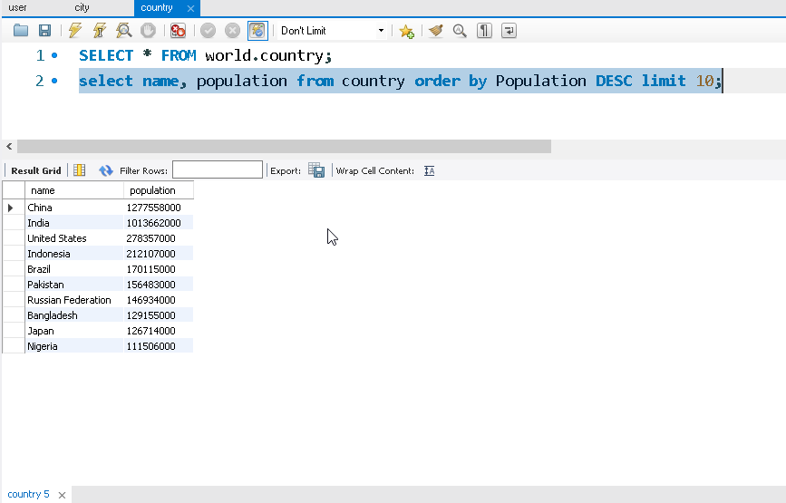

Q3) select name, population from city
where CountryCode="CHN" order by Population DESC;

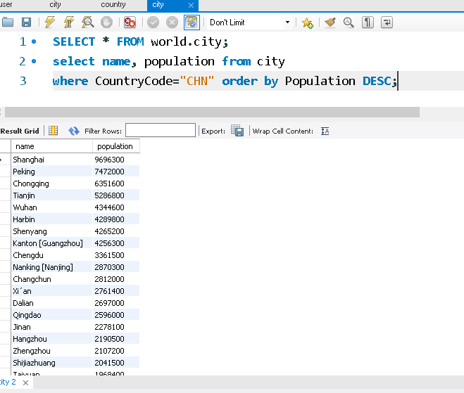

Q-4) SELECT sum(Population) FROM world.country
where Continent="asia";
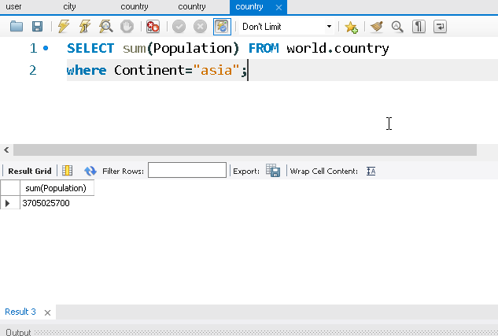

Q4) select avg(population) from world.city
where CountryCode="USA";

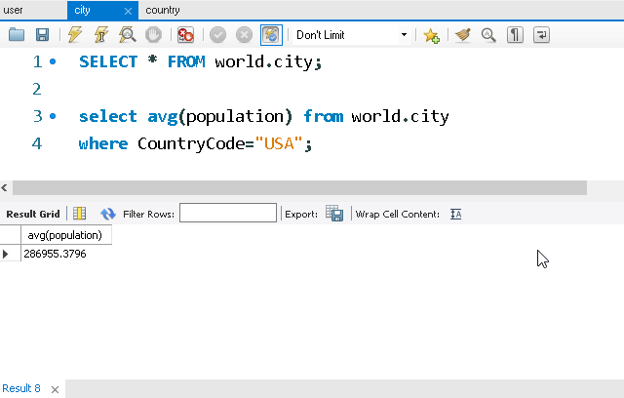

Q5) select continent, count(Continent) from world.country
group by Continent;

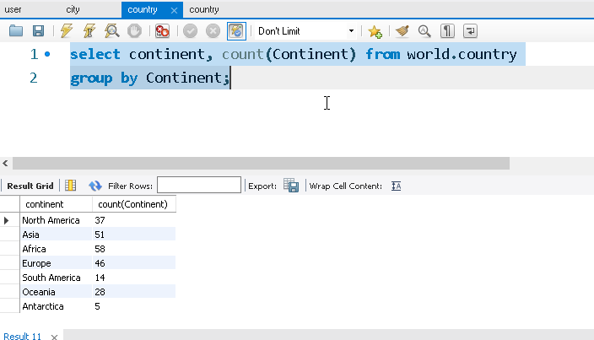

Q5 - SELECT Continent, avg(LifeExpectancy) as avg_life_expectancy FROM world.country
group by Continent;

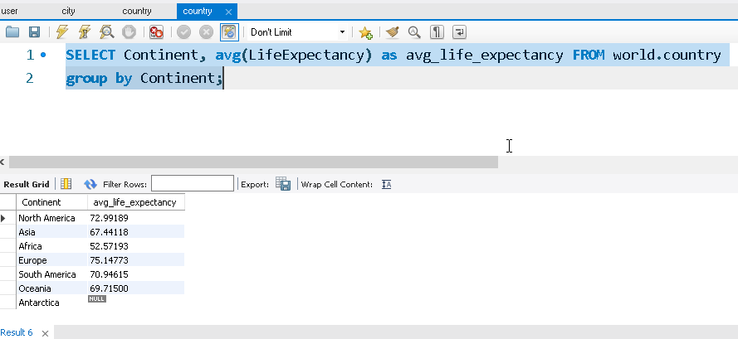

Q6) - select city.name, country.name
from city
join country
on city.CountryCode=country.Code;

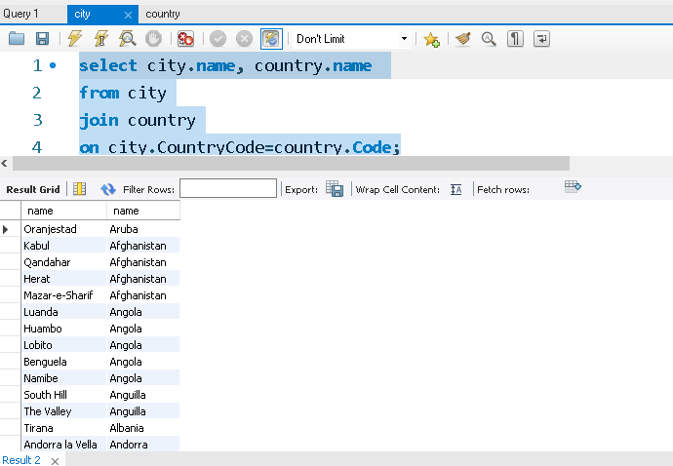

select country.name as country, countrylanguage.Language
from country
join countrylanguage
on country.code=countrylanguage.CountryCode;

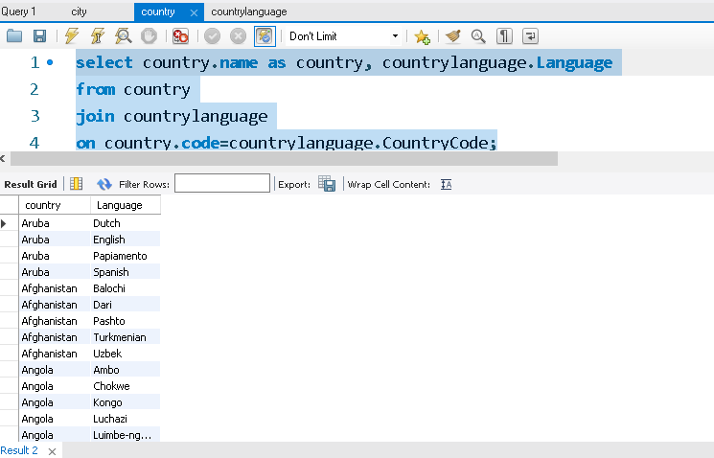

Q7) SELECT name, Population FROM country
where Population = (select max(Population) from country);

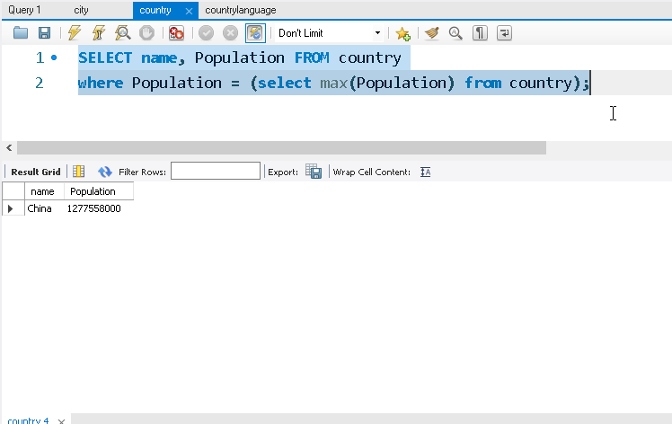

select name, population from city
where Population > (select avg(Population) from city);
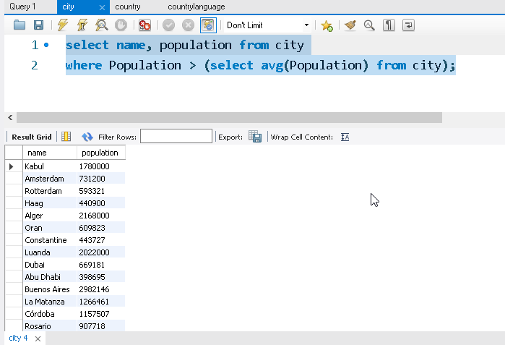

Q8) select name from country where name like "A%";

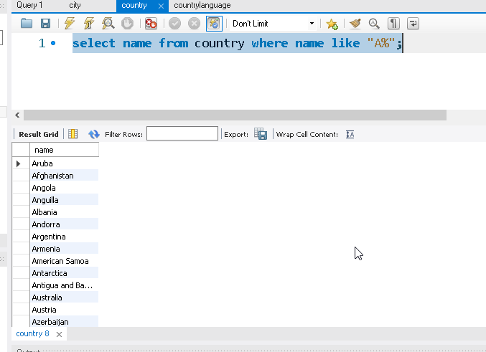

select name from city
where name like "%York%";

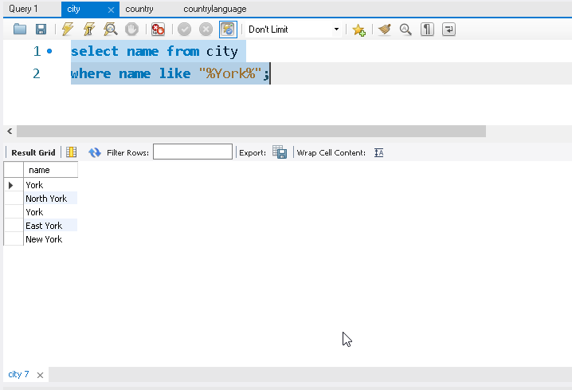

Q9) update city
set population = population *1.10
where countryCode="JPN";
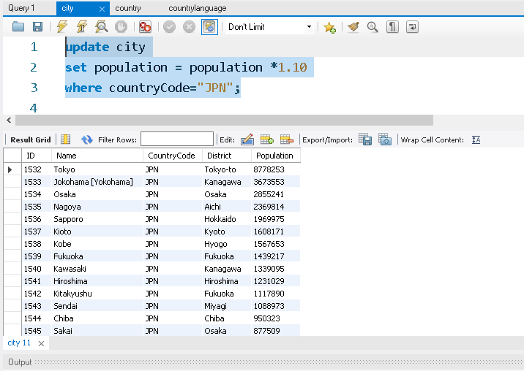

update country
set continent ="Oceania"
where name = "Australia";

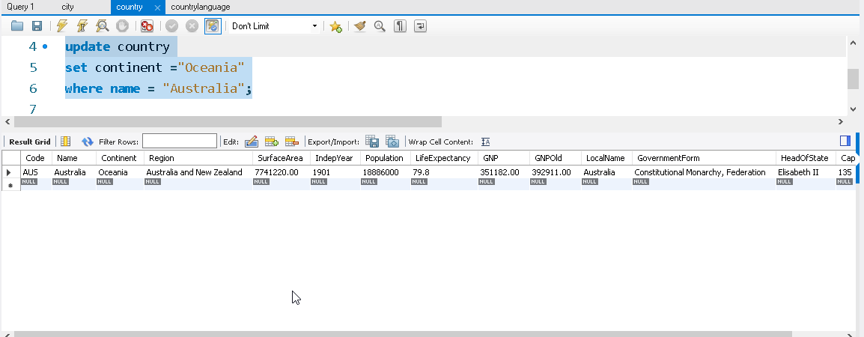

Q10) select * from city where Population<500;
